Setting up application environment

Create Flask Project

(Customer Care Registry_PNT2022TMID52279)

**STEP -1**

Install python from python.org

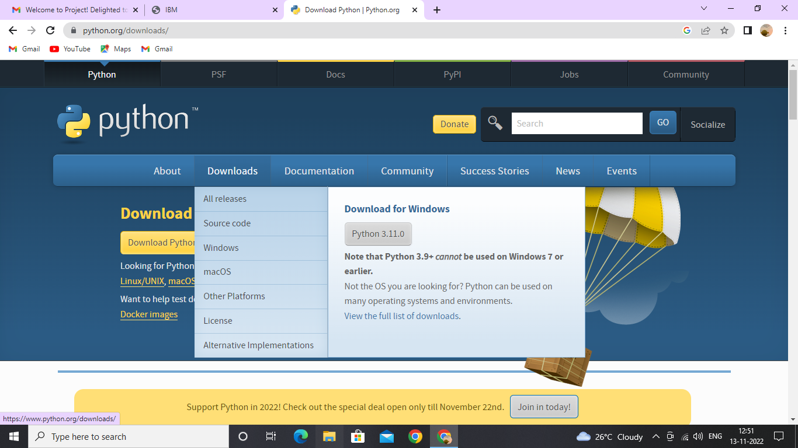

**STEP-2**

Check the version of python,pip using Cmd

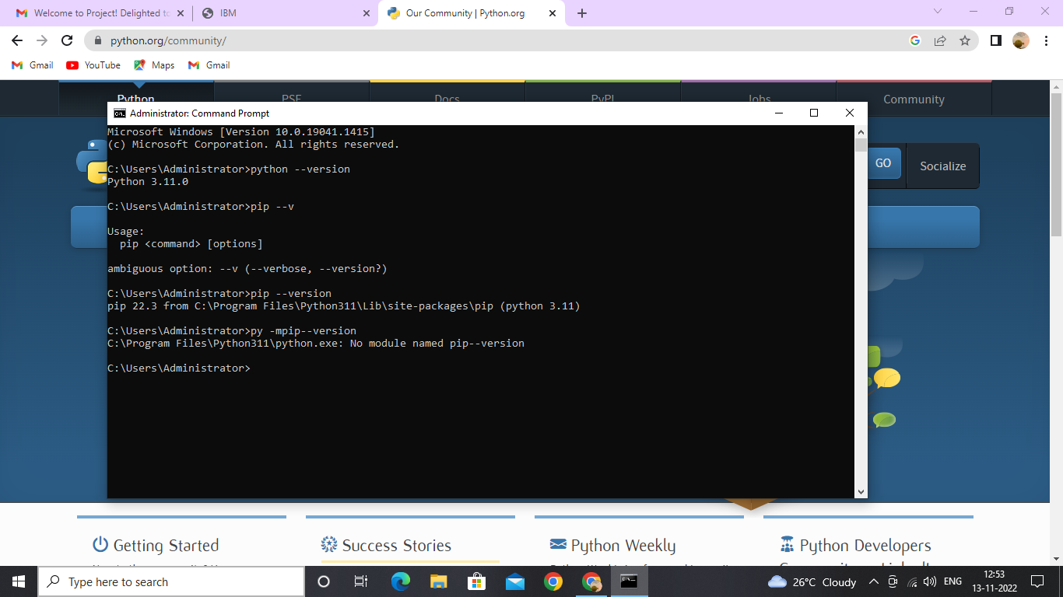

**STEP-3**

Check IDLE ,whether the flask is available.(using import flask command)

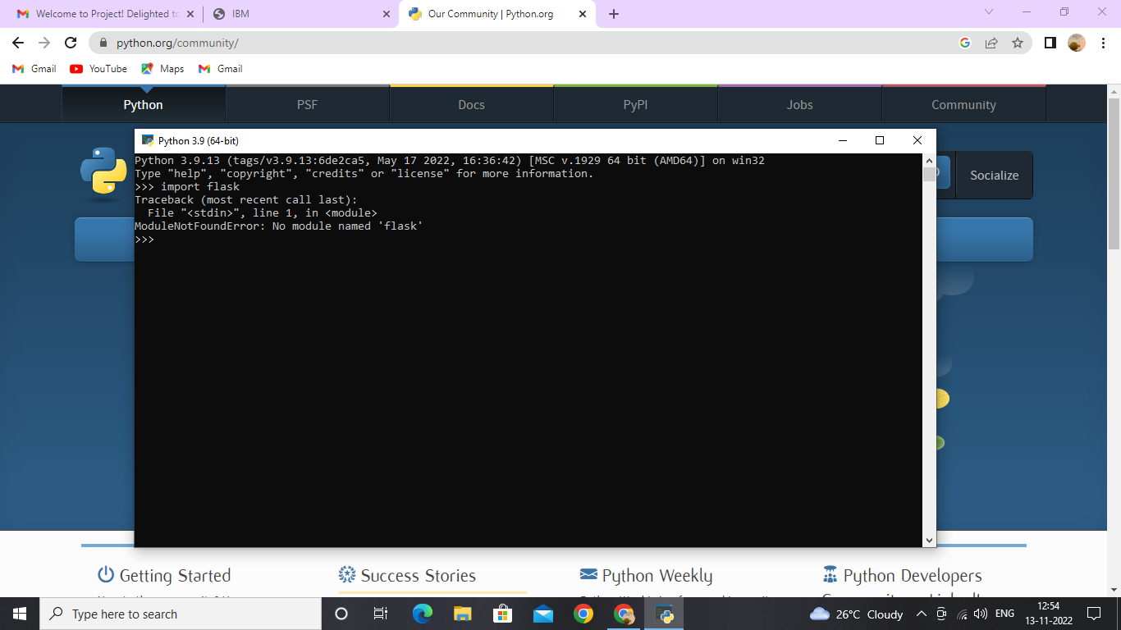

**STEP-4**

Create flask using command (pip install flask)

